**PSP Estimating Worksheet**

**1. Conceptual Design**

**(Sketch your design here)**

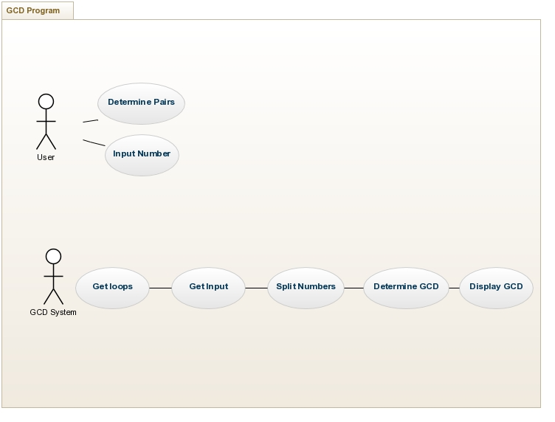

|  |  |
| --- | --- |
| **2. Module Estimates** |  |
| **Module Description** | **Estimated Size** |

User Input 50

GCD Determination 50

Print Array 20

Menu 50

**TOTAL ESTIMATED SIZE: _170_______**